# Design the application UI

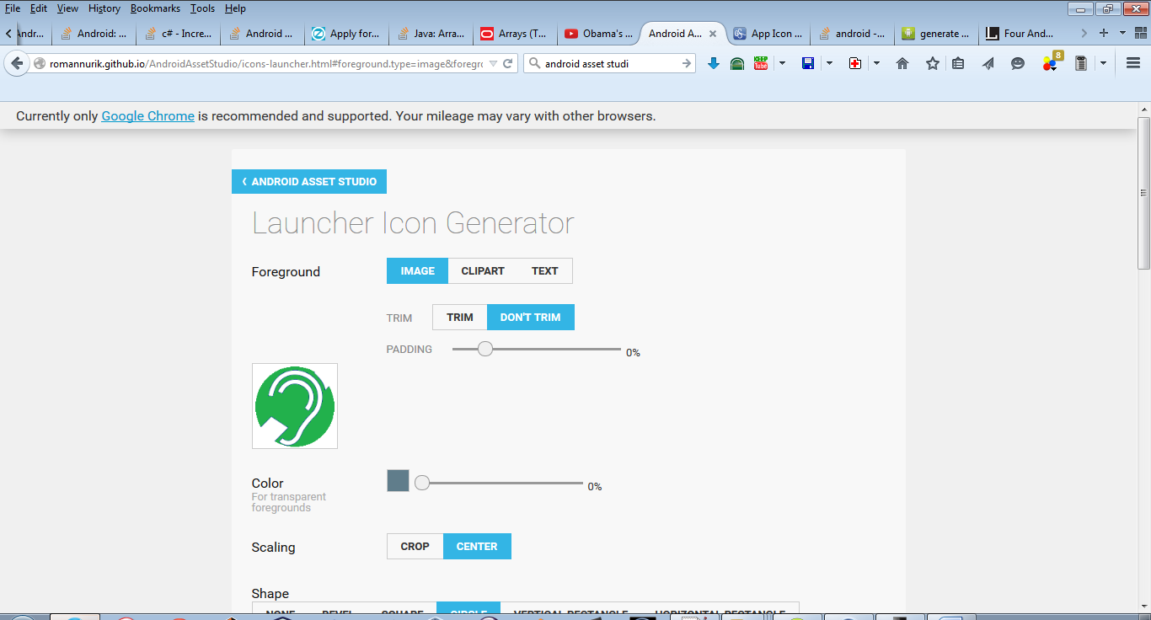

Creating the app icons with correct dimensions using android asset studio



Simple green app launcher icon

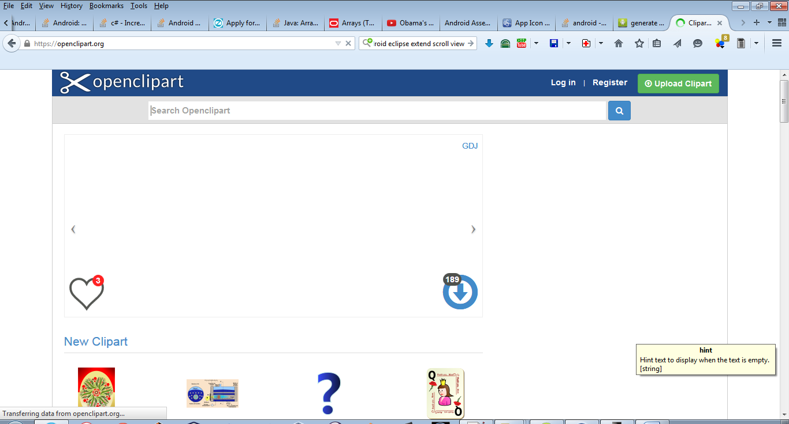

Open clip art

http://angrytools.com/android/button/